Gaussian Splatting

Gaussian Splatting is a form of photo scanning or photogrammetry, I'd like to look at editing and merging splats to create unique and novel environments for use in games, education, advertising etc. I see the possibilities as almost endless.

Instead of drawing a point as a sharp pixel, Gaussian Splats create a soft, blurred effect. This helps create smooth transitions and blending in point cloud rendering.

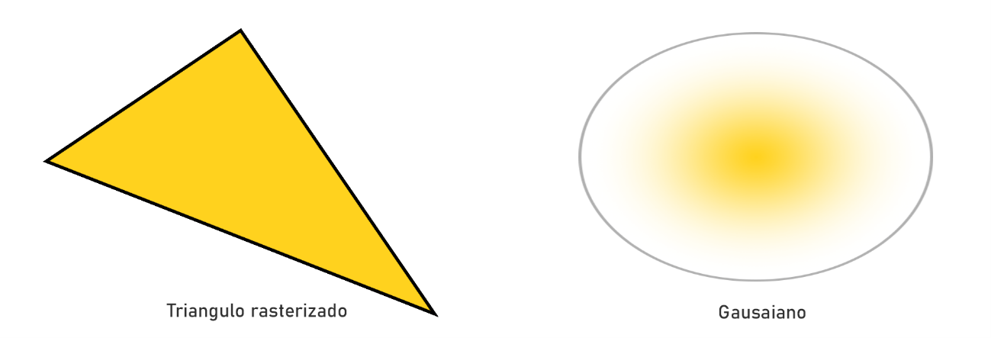

For more visual reference, [Luma AI](https://lumalabs.ai/interactive-scenes) has many examples of Gaussian Splats or “Interactive Scenes” (Their pretentious name for Gaussian Splats)

Gaussian Splatting is not a new process, it has been a concept since the 90s, but in recent years there have been many advancements. There are other types of photo scanning that have seen advancements such as more traditional photogrammetry, Nerf (Neural radiance fields) and the most recent advancement SMERF. I would primarily be looking at Gaussian Splatting, but the other techniques may be worth looking at for comparison.

I worked briefly with Gaussian Splats during my work placement at ACE, I would be interested in the possibility of using their camera equipment to improve the quality of my splats and refine the process.

There are already papers and research done on gaussian splatting. My unique angle would be editing and merging them, which I have not found many examples of.